# Aryan Sai Venkat 230701040

# CSE A

EXP NO:9 Bankers Deadlock Avoidance algorithms

## PROGRAM

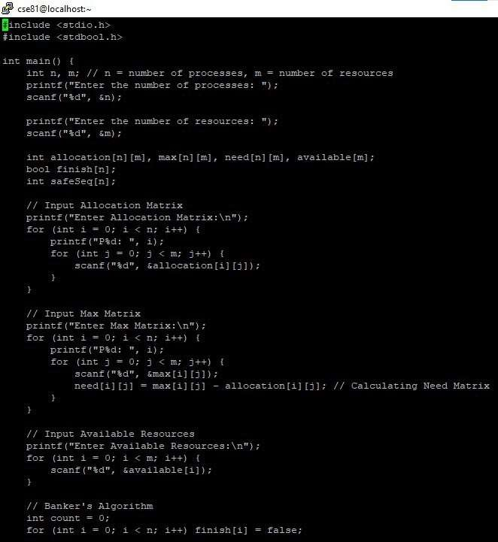

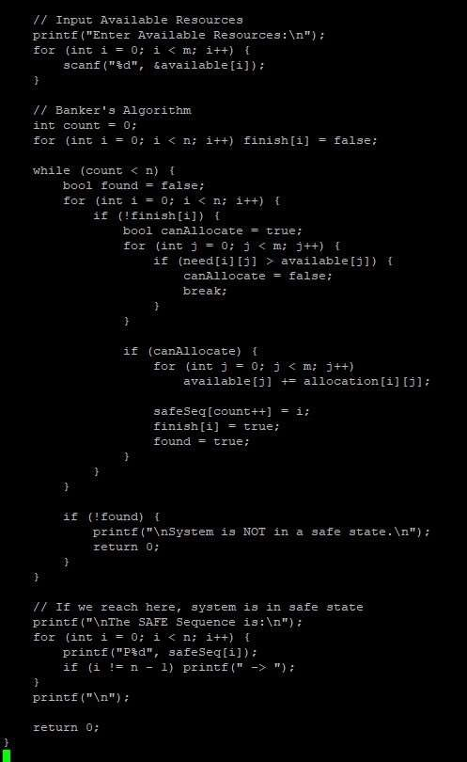

## OUTPUT

